**Index Number – 210098R**

**Name – De Silva APC**

In general, the iterative implementation of merge sort is faster than the recursive implementation due to the overhead of function calls and stack management in recursive functions.

**Chart -**

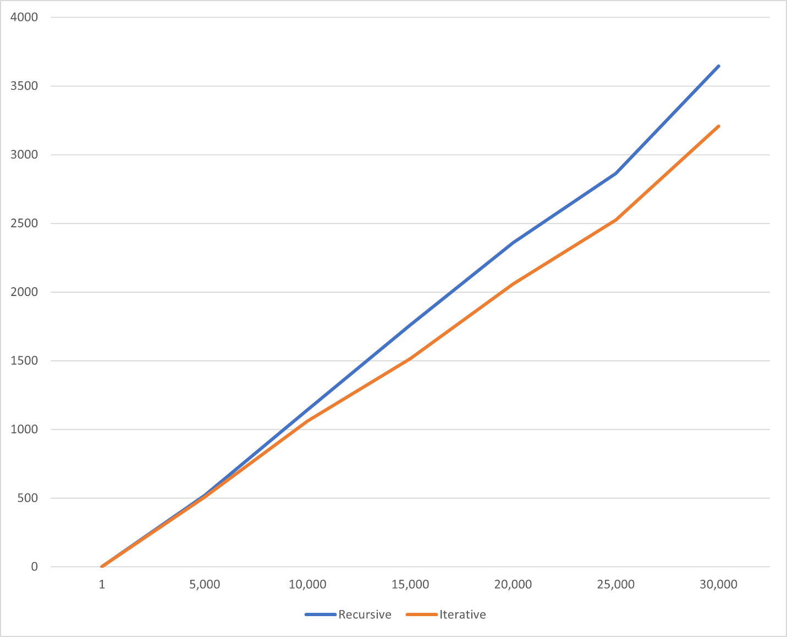

**Data table -**

